Introduction to the OSI Model and Detailed Analysis of Attacks at Each Layer

### Company: Senselearner Technologies Pvt. Ltd.

### Group Name: Hosta

### Submitted by: Darshan Patel (Member)

**Overview:**

The OSI (Open Systems Interconnection) model is a conceptual framework that provides a structured approach to understanding and implementing network protocols. It consists of seven layers, each serving a specific purpose in the communication process. This report provides an introduction to the OSI model and offers a detailed analysis of common attacks that can occur at each layer. By understanding the vulnerabilities at each layer, network administrators can better protect their systems and mitigate potential security risks.

**Introduction:**

The OSI (Open Systems Interconnection) model is a conceptual framework that standardizes the functions of a communication system into seven different layers. Each layer has specific responsibilities and interacts with adjacent layers to facilitate the transfer of data between devices. It provides a systematic approach to understanding network protocols and the flow of information in a networked environment.

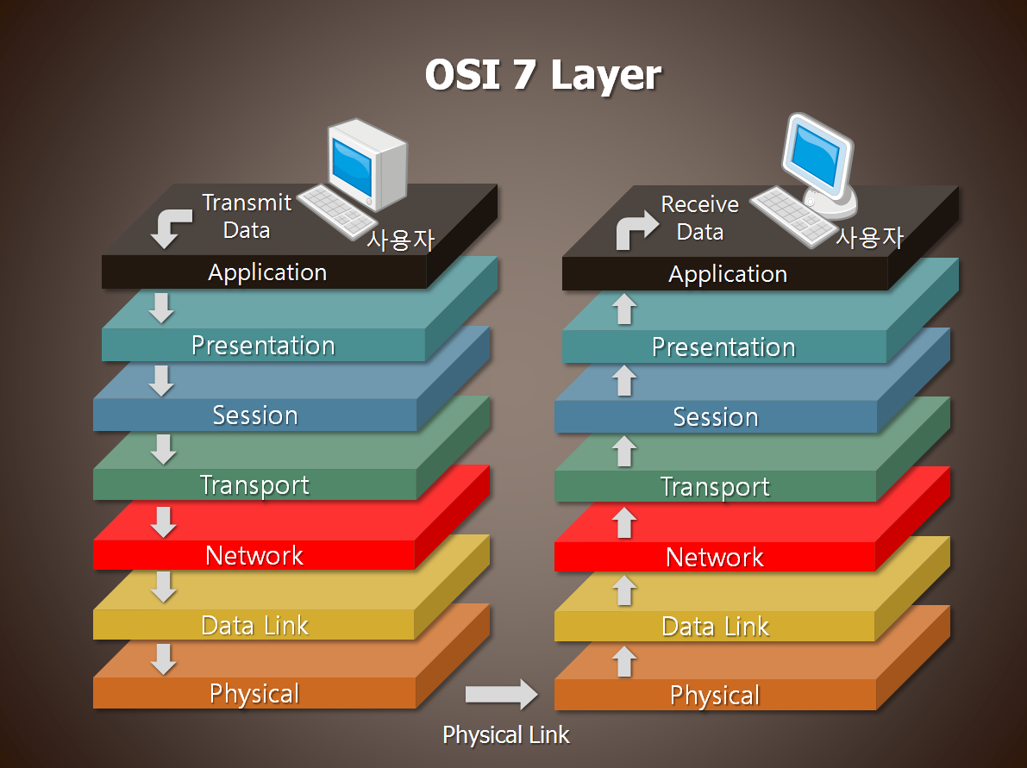

# **Attacks and Mitigation (each layer):**

**1. Physical Layer:**

The Physical Layer is responsible for transmitting raw bit streams over physical media. Attacks at this layer often target the physical components of a network, such as cables, connectors, or network devices.

- Wiretapping: Unauthorized individuals intercept and monitor the communication signals by physically tapping into the network cables.

- Eavesdropping: Attackers can tap into physical network cables or use specialized equipment to intercept and capture network traffic.

Mitigation: use of secure encryption technologies, such as VPN

**2. Data Link Layer:**

The Data Link Layer provides reliable node-to-node data transfer and handles error detection and correction. Attacks at this layer focus on manipulating or disrupting data link connections.

- MAC Address Spoofing: An attacker modifies their network interface card's (NIC) MAC address to masquerade as another device, allowing unauthorized access.

- ARP Spoofing/ARP Poisoning: Attackers send forged Address Resolution Protocol (ARP) messages to associate their MAC address with the IP address of a legitimate device, intercepting network traffic.

Mitigation: MAC address filtering and dynamic ARP inspection

**3. Network Layer:**

The Network Layer is responsible for logical addressing and routing of data packets between networks. Attacks at this layer exploit vulnerabilities in routing protocols or target the network infrastructure.

- IP Spoofing: Attackers forge the source IP address of packets to appear as if they originated from a trusted source, bypassing access controls.

- ICMP (Internet Control Message Protocol) attacks: Attackers send malicious ICMP packets, such as ICMP floods or ICMP redirect attacks, to disrupt network connectivity.

Mitigation: Access control lists (ACL’S), Firewall, Disabling ICMP functionality

**4. Transport Layer:**

The Transport Layer ensures reliable delivery of data between end systems. Attacks at this layer often target the transport protocols or exploit vulnerabilities in the network's session management.

- SYN Flooding: Attackers overwhelm a server's resources by sending a large number of TCP SYN packets, causing the server to become unresponsive to legitimate requests.

- TCP Session Hijacking: Attackers intercept and take control of an established session, allowing them to masquerade as a legitimate user and gain unauthorized access.

Mitigation: Intrusion Prevention system, Load balancer, Transport Layer Security (TLS)

**5. Session Layer:**

The Session Layer establishes, manages, and terminates communication sessions between applications. Attacks at this layer aim to disrupt or hijack session-related activities.

- Session Hijacking: Attackers exploit vulnerabilities in session management to hijack ongoing sessions and gain unauthorized access.

- Man-in-the-Middle (MitM): Attackers intercept and alter communication between two parties, allowing them to eavesdrop or manipulate data.

Mitigation: Encryption, Use of Secure Protocols, session management controls

**6. Presentation Layer:**

The Presentation Layer ensures that data exchanged between applications is properly formatted, encrypted, and interpreted. Attacks at this layer focus on exploiting vulnerabilities in data formatting or encryption mechanisms.

- Encryption Attacks: Attackers attempt to break the encryption algorithms used to secure data, such as brute-forcing encryption keys or leveraging weak encryption protocols.

- Malformed Data: Attackers send malformed or specially crafted data to exploit vulnerabilities in the way applications interpret and process data.

Mitigation: Use of strong encryption algorithms and proper key management practice, Input validation, parameterized queries, WAF

**7. Application Layer:**

The Application Layer provides a user interface and services for applications to access network resources. Attacks at this layer target specific applications or services.

- SQL Injection: Attackers exploit vulnerabilities in web applications by injecting malicious SQL queries, potentially gaining unauthorized access to the underlying database.

- Cross-Site Scripting (XSS): Attackers inject malicious scripts into web pages viewed by users, allowing them to steal sensitive information or perform unauthorized actions.

Mitigation: Secure coding practice, Input validation, Web application firewall

# **Case Studies:**

**Case Study 1: Stuxnet Attack on Industrial Control Systems**

Overview:

The Stuxnet worm is one of the most infamous cyberattacks in history, targeting industrial control systems (ICS) and specifically aiming at Iran's nuclear facilities. The attack, discovered in 2010, exploited vulnerabilities across multiple layers of the OSI model.

Impact and Consequences:

1. Physical Damage: Stuxnet targeted programmable logic controllers (PLCs) used in centrifuges for uranium enrichment. By manipulating the ICS, the attackers were able to cause the centrifuges to spin at incorrect speeds, resulting in physical damage and reducing their operational efficiency.

2. National Security Implications: The Stuxnet attack was a state-sponsored attack aimed at sabotaging Iran's nuclear program. It demonstrated the potential for cyberattacks to disrupt critical infrastructure and impact national security on a global scale.

3. Escalation of Cyber Warfare: Stuxnet represented a significant escalation in cyber warfare tactics, showcasing the capability to cause physical damage through targeted attacks on industrial systems. This attack set a precedent for future attacks on critical infrastructure worldwide.

Countermeasures:

1. Patching and Updates: The vulnerabilities exploited by Stuxnet were patched after the attack was discovered. Regular updates and security patches are crucial to address known vulnerabilities and protect against similar attacks.

2. Network Segmentation: Implementing network segmentation between corporate networks and ICS can help isolate critical infrastructure from external threats. By limiting access points, it becomes harder for attackers to move laterally across the network and reach sensitive systems.

3. Enhanced Security Awareness and Training: Organizations need to educate employees about the risks of social engineering and phishing attacks, which are often used as entry points for sophisticated attacks like Stuxnet. Security awareness programs can help employees identify and report suspicious activities.

**Case Study 2: WannaCry Ransomware Attack**

Overview:

The WannaCry ransomware attack in 2017 was a global cyberattack that exploited vulnerabilities in the Microsoft Windows operating system, targeting organizations across various industries. It primarily targeted the SMB protocol, operating at the application layer of the OSI model.

Impact and Consequences:

1. Widespread Disruption: WannaCry spread rapidly, infecting hundreds of thousands of computers worldwide. It disrupted critical services in hospitals, transportation systems, and government agencies, causing significant operational downtime and financial losses.

2. Financial Impact: The attack resulted in financial losses estimated to be in the billions of dollars. Organizations faced costs associated with system recovery, ransom payments, and reputational damage.

3. Public Safety Concerns: Healthcare institutions were severely impacted by WannaCry, with disruptions to patient care and medical services. The attack raised concerns about the potential consequences of cyberattacks on public safety and critical infrastructure.

Countermeasures:

1. Regular Patching: The WannaCry attack exploited a vulnerability in older versions of Windows operating systems. Organizations that promptly applied the security patch released by Microsoft were protected from the attack. Regular patching and updates are vital to address known vulnerabilities.

2. Network Segmentation and Access Controls: Implementing network segmentation and robust access controls can limit the lateral movement of malware within an organization's network. Separating critical systems from less critical ones can help contain the impact of an attack.

3. Backup and Disaster Recovery: Maintaining regular backups and a comprehensive disaster recovery plan is essential to mitigate the impact of ransomware attacks. Having offline backups stored securely ensures that organizations can recover their systems without paying the ransom.

References:

[Common Security Attacks in the OSI Layer Model (infosectrain.com)](https://www.infosectrain.com/blog/common-security-attacks-in-the-osi-layer-model/)

[OSI: Securing the Stack, Layer 5 -- session hijacking | TechTarget](https://www.techtarget.com/searchnetworking/tip/OSI-Securing-the-Stack-Layer-5-session-hijacking)

[(PDF) A Study on Different Attacks on Transport, Network and Data Link Layer in TCP/IP (researchgate.net)](https://www.researchgate.net/publication/322653426_A_Study_on_Different_Attacks_on_Transport_Network_and_Data_Link_Layer_in_TCPIP)

[Case Study: WannaCry Ransomware - SDxCentral](https://www.sdxcentral.com/security/definitions/what-is-ransomware/case-study-wannacry-ransomware/)

[(PDF) Stuxnet (researchgate.net)](https://www.researchgate.net/publication/323199431_Stuxnet)